Atlanta Business Chronicle- Kickball & Wellness at Winter Companies

Winter and its leader, Brent Reid, CEO, are serious about employee wellness, both physically and mentally. Recently, the company switched over to Humana Vitality, a program that rewards and incents both the employee and the company for participation. By inspiring Winter employees to make healthy changes and reach personal goals, employees benefit and the company benefits in lower healthcare costs.

Brent took it a step further and bought everyone in the company a Fitbit, an activity tracking device, in an effort to have 60% of the company reach silver status by a specified date and cash in on the 10% reduction in Winter’s healthcare expenses.

As a result of his commitment, Winter employees not only responded, they far exceeded expectations.

We reached 60% within just a few months of launching and are now at 100% in less than a year. There is only one other company in the United States that has reached 100% and they didn’t even accomplish it until year two.

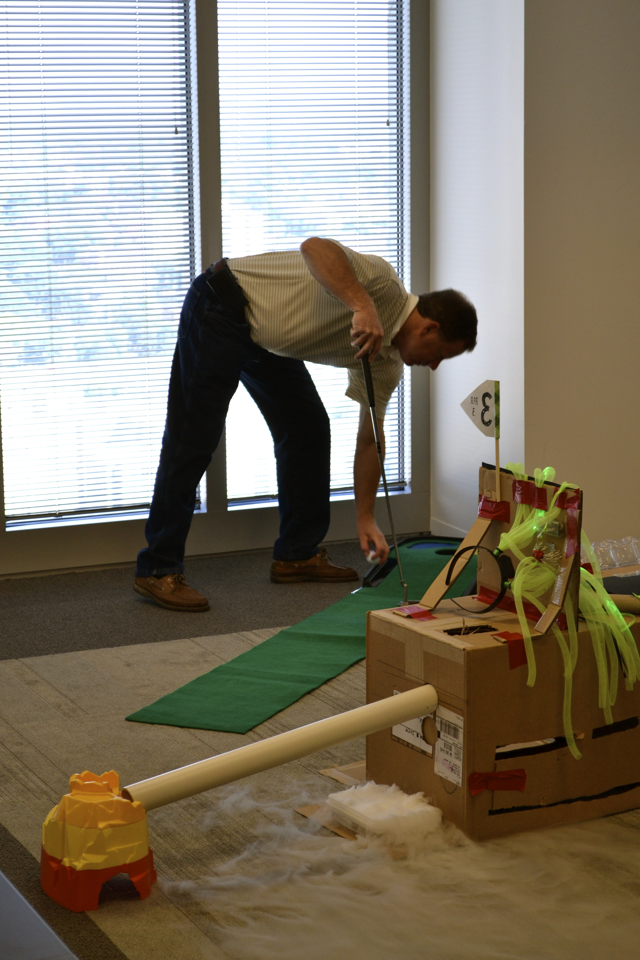
In addition, 20% have already reached Gold status and 10% Platinum status. We are on track to have 40% gold and 20% Platinum by year end.

Aside from activity tracking devices that encourage more steps, increased daily water intake, and elevated activity in general, Winter also is committed to mental and spiritual wellness. Winter has a special Funstruction committee that is dedicated to planning and executing fun company activities such as happy hours and in-office athletic events like Winterlympics and Putt Putt tournaments.

Recently Carol Swanson, HR Director and Matt Atkins, HR Coordinator made the decision to change from participating in a softball league, that was somewhat serious and competitive, to a kickball league. “People have a limited amount of time and need to distress. We needed an athletic activity that appealed to a wide array of people and wasn’t too physically rigorous to complement what we were already doing.” said Swanson. “ Who doesn’t love kickball? It’s synonymous with drinking out of the hose in the summertime” added Atkins.

The Winter Warriors, consisting of roughly 25 Winter employees from age 21 to 53 year olds, won 5 of their 8 games this year.

“We had a great time and did pretty well; a lot better than we did in softball and people seemed to enjoy it more as it was lighter and more casual. Also, if someone had to miss it was easier to replace that person given the less technical of a sport.
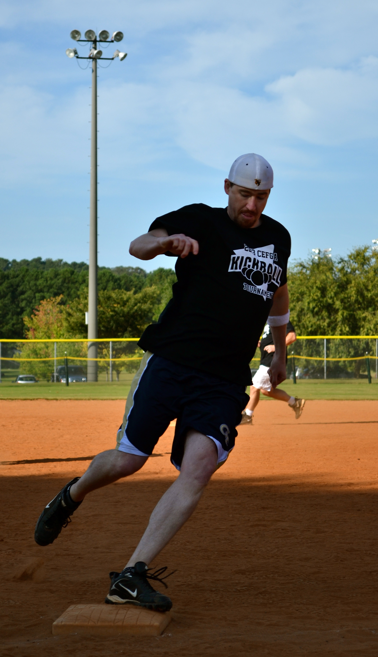

Playing in Piedmont Park was also an advantage, we usually ended up going out to a nearby bar or restaurant afterwards or watched set up for a festival which would spur another social gathering. The recent college graduates new to Atlanta especially appreciated this, stated Matt Atkins, Winter Warriors team coach.

