 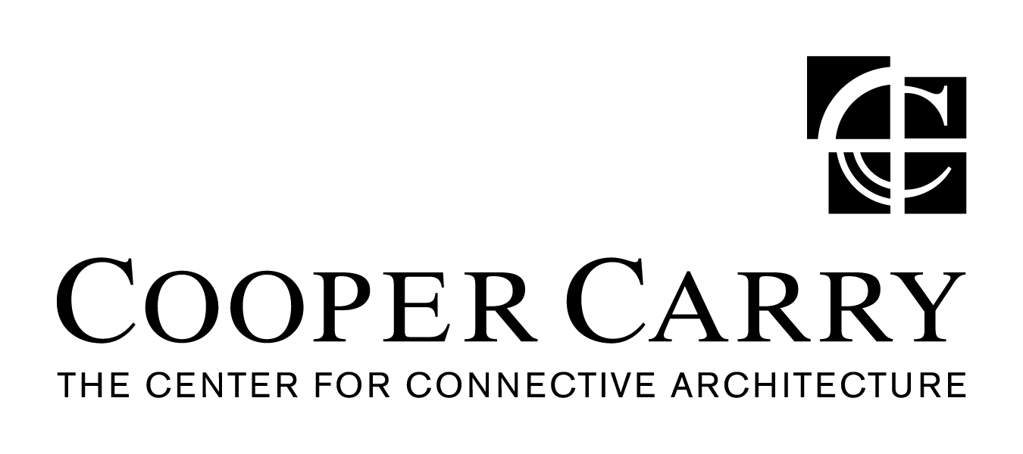

**PRESS RELEASE**

**Winter Construction Awarded Decatur High School Renovation and Expansion Project**

(August 4, 2014) ATLANTA, GA – City Schools of Decatur recently selected Winter Construction and Cooper Carry Architects as the design/build team for the renovation and expansion of Decatur High School in Decatur, Georgia. The project, part of the City Schools of Decatur Capital Improvement Plan, will be a multi-year, multi-phased initiative phased with construction completion expected in Fall of 2016. This will be Winter’s second project with City Schools of Decatur having completed the stadium renovation and new Decatur Performing Arts Center in 2007.

The project scope consists of a full renovation of the existing campus, including restoration and reconfiguration of the existing main building, parking and drop-off improvements, and additional construction of a new building. Renovated spaces include the existing cafeteria and kitchen, media center, support spaces, utility infrastructure, administrative spaces, and additional classrooms.

Winter is, again, committed to creating an environment that fosters collaboration among the school staff, parents and the community.

Being a design-build project in a collaborative atmosphere with Owner representative, City of Decatur Schools representatives and the Decatur community, we are looking to implement some aspects of Integrated Project Delivery:

* Lean Design and Construction, including pull planning
* Building Information Modeling (BIM) including laser scanning, 3D coordination and FIM
* Big Room
* Trade Partners
* Target Value Design

A series of community input forums will take place throughout the design process. The first of these meetings is scheduled for August 14th at 6:30 PM in the Decatur High School Performing Arts Center.

###

**About Winter**

*Winter is a privately owned and operated Atlanta based general contracting company. We provide* *construction and environmental services to clients in the hospitality, retail, government, education, corporate/office, religious, healthcare, historic restoration, industrial and multifamily markets in the* *Southeast. For more information visit:* [*http://www.winter-construction.com*](http://www.winter-construction.com)

Media Contact: Giffney Nagel, Marketing Director, Winter Construction, 404-993-4574

###

**About Cooper Carry**

*Cooper Carry provides architecture, planning, landscape architecture, interior design, environmental graphic design and sustainability consulting services. Founded in 1960, the firm specializes in the design of corporate, education, government, hospitality, mixed-use, office, residential, retail, science + technology, and transit projects. The firm has designed projects in 45 states and globally in the Caribbean, Middle East, Asia, Africa and Central America. Engaging a fundamental design philosophy centered on the concept that environments should connect people to people and people to place, the firm promotes the philosophy of “connective architecture.” Designers understand the local market and the specific cultural and physical contexts in which the building will serve those who interact with it while conceiving memorable spaces, inside and out. Listening to the client and gaining a deep understanding of the market and site prior to commencing design, Cooper Carry balances passionate creativity with client service. For more information visit* [*coopercarry.com*](http://www.coopercarry.com/)*.*

Media Contact: Liana Moran, The Wilbert Group, 404-748-1367

###