** PRESS RELEASE**

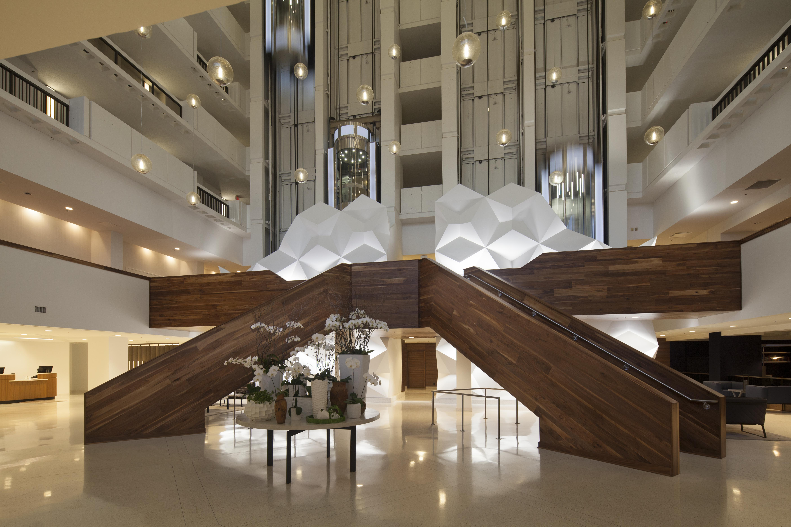

**Winter Construction Completes Two Complex Hotel Renovations in Downtown Nashville**

(November 6, 2014) ATLANTA, GA - Winter Construction recently completed renovations of the Hilton Nashville Downtown Hotel and the Sheraton Nashville Downtown Hotel. These completions add to a growing list of Winter’s hospitality projects in which unique design features have required innovative construction methods in occupied facilities.

The Hilton Nashville Downtown Hotel renovation included refurbishment of all 330 guest rooms, the presidential suite, and the main lobby and lobby bar. The indoor pool area was transformed to include a concierge lounge and a fitness center. Complex exterior work included replacing the existing high atrium lobby skylight with a more architecturally pleasing and energy-efficient skylight.

Winter also completed renovation of the Sheraton Nashville Downtown Hotel which included the main lobby, wine bar, main and rear entrances, ballrooms, prefunction areas, meeting and conference rooms and public restrooms.

The Sheraton’s renovated lobby and atrium contain numerous unique design features including a suspended grand staircase, 13 chandelier pendant lights suspended from the framed skylight of the 26-story atrium that spans down to the second-floor terrace level, a 25-foot-high geometric, sculptural feature that also functions as safety wall separating lobby guests from the external elevator cars.

These unique features, like the Hilton’s atrium and skylight, required care and innovation in their installations. To install the Sheraton’s atrium lighting system while the hotel was occupied, Winter devised a motorized platform/stage to gain access to the upper atrium space, since traditional scaffolding and other methods were not workable.

“I’m proud of how our field team solved these field installation challenges,” said Ken Smith, Director of Hospitality for Winter Construction. “Not only were they able to engineer an unprecedented solution, they were able to do so while maintaining safety requirements for both the team and the hotel guests.”

*About Winter:*

*Winter is a privately owned and operated Atlanta based multidisciplinary general contracting company. We provide construction and environmental services to clients in the hospitality, retail, government, education,*

*corporate/office, religious, healthcare, senior living, industrial and multifamily markets in the*

*Southeast. For more information visit:* [*http://www.wintercompanies.com*](http://www.wintercompanies.com)

Media Contact:

Giffney Nagel, Marketing Director, Winter Construction, 404-993-4574

################