

**PRESS RELEASE**

**Winter Construction Breaks Ground at Canterfield of Franklin Senior Living Facility**

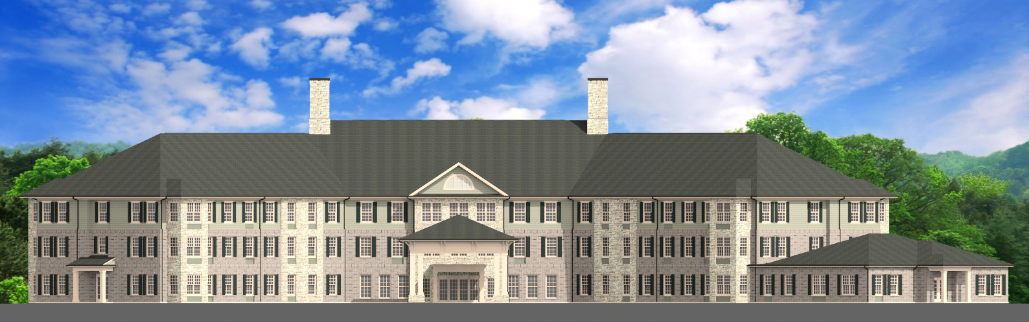

(November 4, 2015) ATLANTA, GA – Winter Construction has begun building the new Canterfield Senior Living facility in Franklin, Tennessee. The facility will be composed of three floors and 74,000 square feet of total space.

Atlanta-based Medical Development Corp (MDC) selected Winter Construction as the general contractor to build the first phase of the new, cost-efficient Canterfield community in Franklin, and similar facilities in Kennesaw, GA, and Bluffton, SC. The expected completion date for the first phase of these facilities is fall 2016.

MDC launched the Canterfield luxury senior living brand in 2011. Because MDC is involved in hotel and restaurant properties, the Canterfield concept utilizes both the continuum of healthcare with the services and amenities of the hospitality industry. Canterfield facilities also allow the resident to age in place, a benefit many communities do not offer, while satisfying each individual’s needs and desires in a country club-like setting.

Atlanta-based architecture firm Corcoran Ota Group designed the Canterfield model with construction pricing efficiency in mind. Future maintenance cost-reduction is also a primary focus of initial building design.

“Winter Construction’s work with Medical Development Corp is the perfect partnership,” said Harry Keller, Senior Project Manager with Winter. “We have experience in both senior healthcare and hospitality. Together, we share the goal of using our strengths to create a senior living facility that offers an unsurpassed standard of living to its residents.”

*About Winter Construction:*

*Founded in 1962, Winter Construction is a privately owned and operated Atlanta-based multidisciplinary*

*general contracting company. We provide construction and environmental services to clients in the*

*hospitality, retail, government, education, corporate/office, religious, senior living, and multifamily markets in the Southeast. For more information visit: http://www.winter-construction.com*

Media Contact:

Sacha Turpin, Director of Marketing, Winter Construction, 404-965-3369

################