Winter Completes 12th school renovation and construction project
for Atlanta Public Schools.

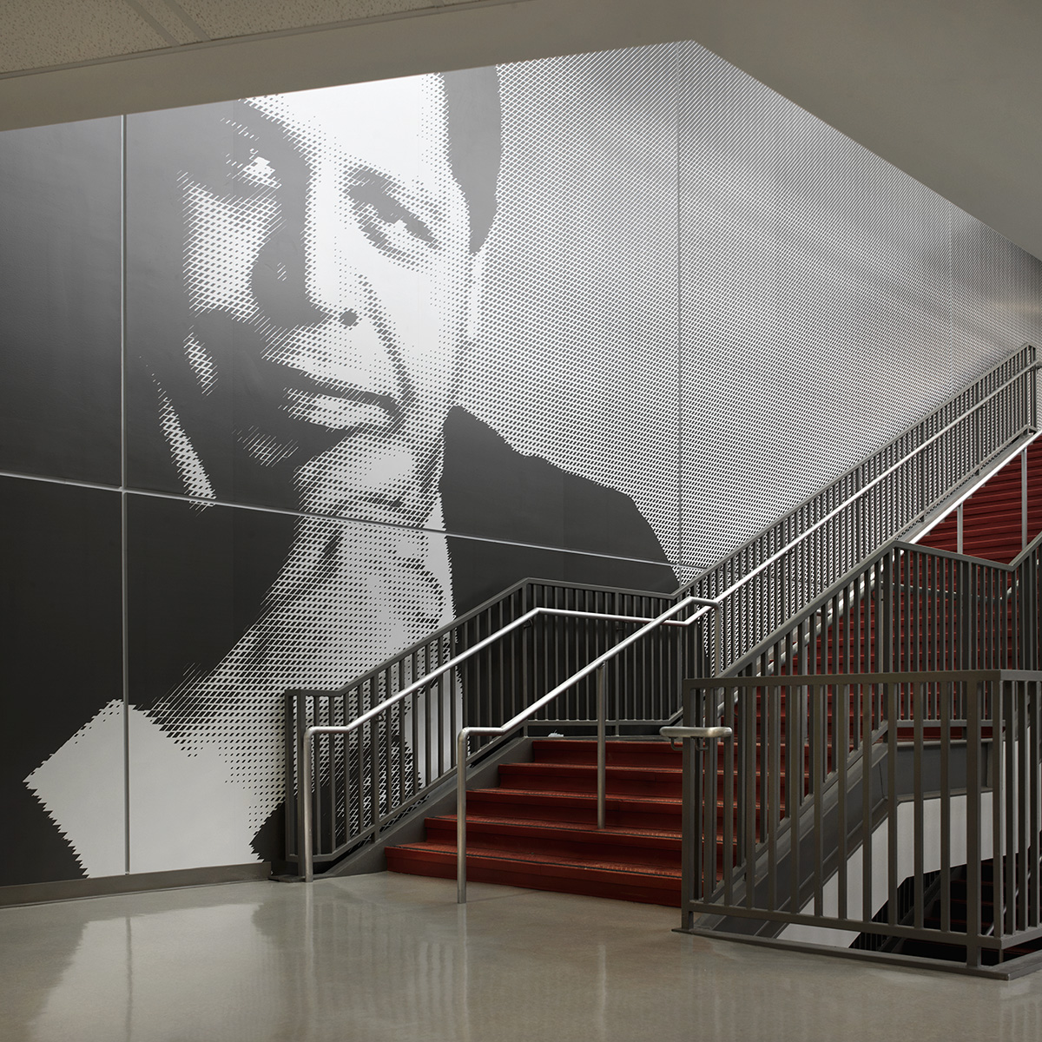

ATLANTA (February 4, 2014)

On January 7, 2014, Winter Construction turned over the first of two phases of the Maynard Jackson High School project consisting of 280,000 square feet of structural renovation and new construction.

Students and faculty returned from the holidays to a refreshed two-story classroom building designed to hold 1,200 students which now includes new science and technology labs, classrooms, a media center complete with a broadcast studio and new outdoor facilities including new football and softball fields and tennis courts.

The renovation required extensive demolition including the existing structure of the main classrooms building in order to allow for the construction of two curtain wall and skylight entry towers and an interior monumental stair. Additionally, interior courtyard walls were demolished to make room for a floor-to-ceiling curtain wall, which brings natural light into a previously dark space. The intricacies of the renovation also included work to restore the existing green roof.

Phase 3 will complete in early Spring of 2014 and will include a new 16,000 square foot gymnasium with a performance court, two practice courts, a weight room, locker rooms, and an ROTC Fire Range. Improved facilities support Maynard Jackson High School’s transition to the International Baccalaureate program and curriculum.

About Winter Construction
Winter is a privately owned and operated Atlanta based contracting company. We provide
construction and environmental services to clients in the hospitality, retail, government, education,
corporate/office, religious, healthcare, historic restoration, industrial and multi-family markets in the Southeast. For more information visit: http://www.wintercompanies.com

Media Contact: Giffney Nagel, Dir. Marketing, Winter Construction
gnagel@winter-construction.com, 404-993-4574

